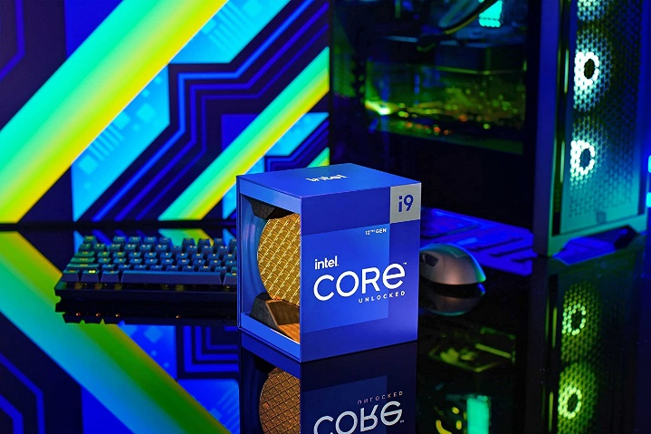

Inner

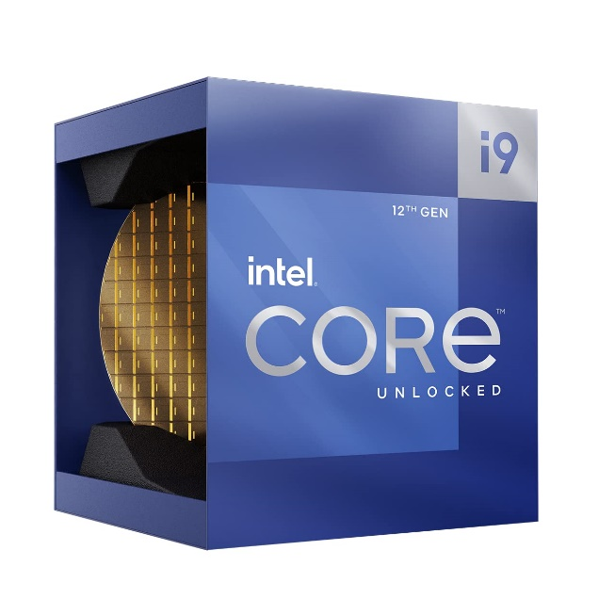

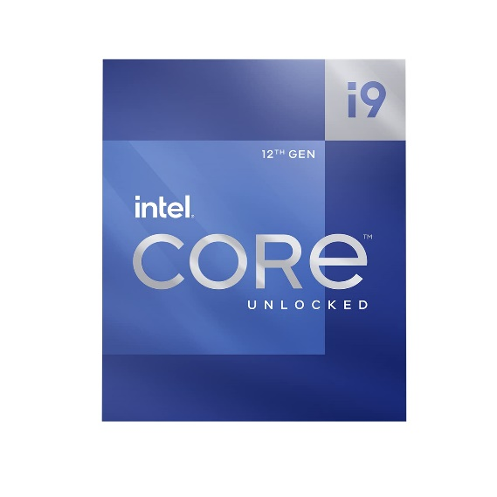

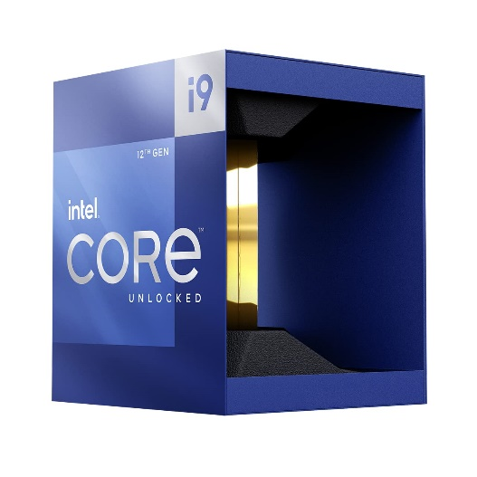

Intel Core i9-12900K Desktop Processor 16 (8P+8E) Cores up to 5.2 GHz Unlocked LGA1700 600 Series Chipset 125W

-32% ₹60,780.00

M.R.P.: ₹89,999.00

|  |  |
| --- | --- |
| Brand | Intel |
| CPU Manufacturer | Intel |
| CPU Model | Core i9-12900K |
| CPU Speed | 5.2 GHz |
| CPU Socket | LGA 1700 |

**About this item**

* The processor features Socket LGA-1700 socket for installation on the PCB
* 30 MB of L3 cache memory provides excellent hit rate in short access time enabling improved system performance
* 10 nm enables improved performance per watt and micro architecture makes it power-efficient
* Intel 7 Architecture enables improved performance per watt and micro architecture makes it power-efficient